**Indirect Cost %**

**Case 1 : Purchase Order:**

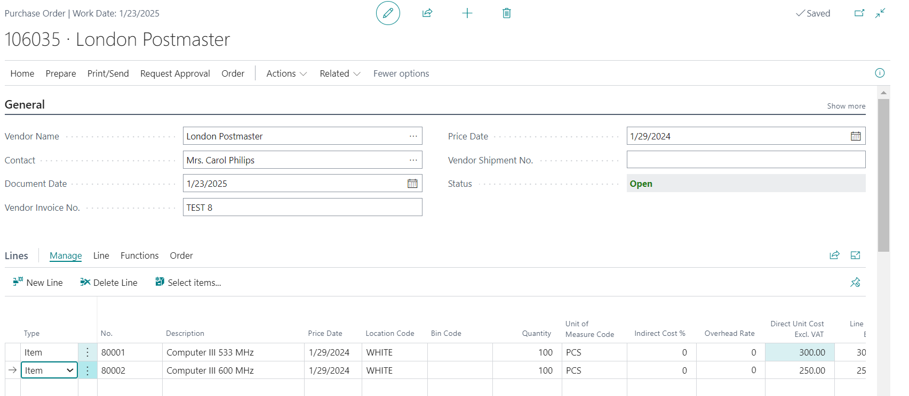

Cost Worksheet:

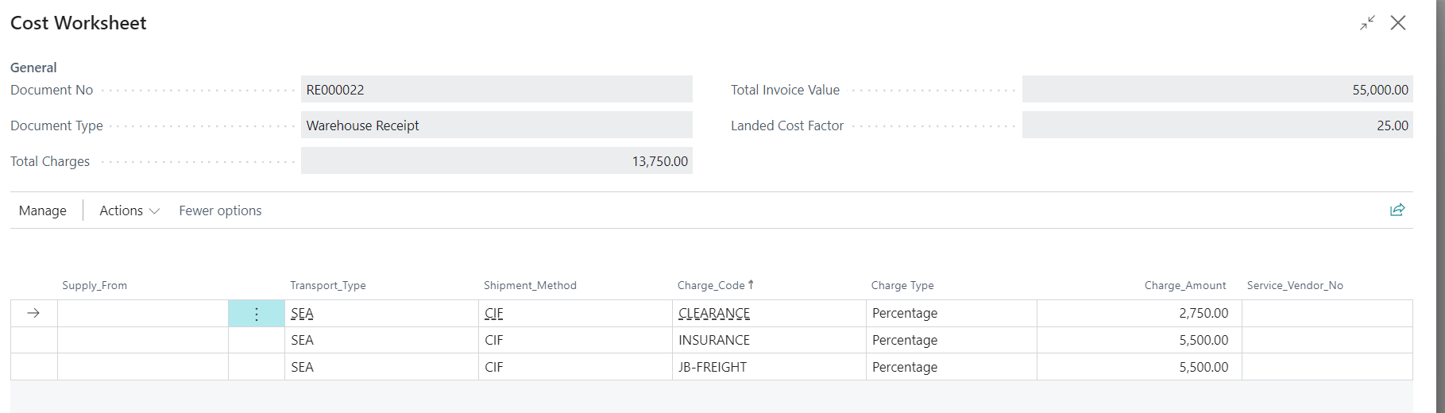

GRN :

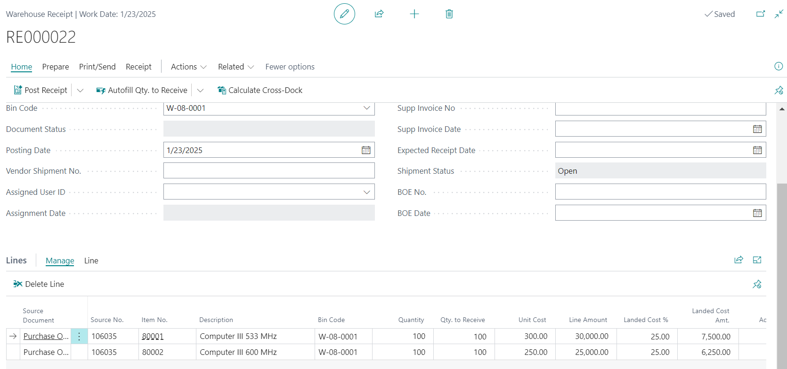

Posted Warehouse Receipt:

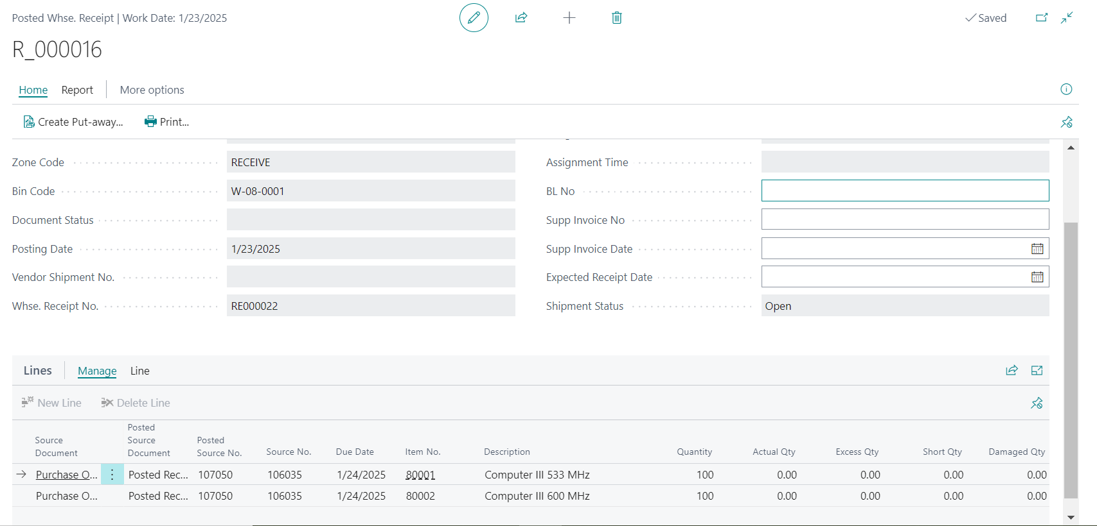

Value Entries:

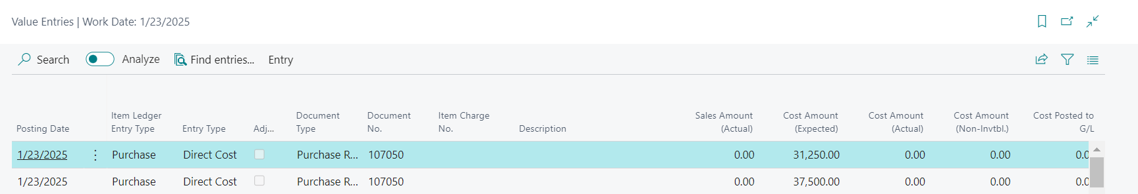

After Purchase Invoice Posted : Value Entries

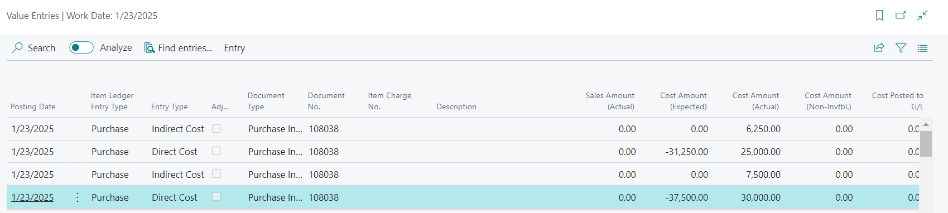

Case 2:

Purchase Order:

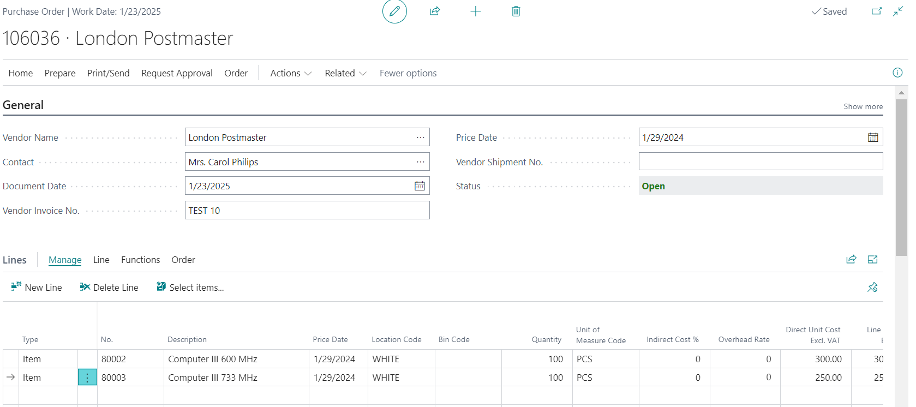

Cost WorkSheet:

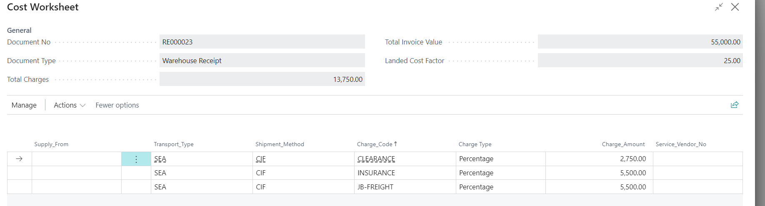

GRN -1: 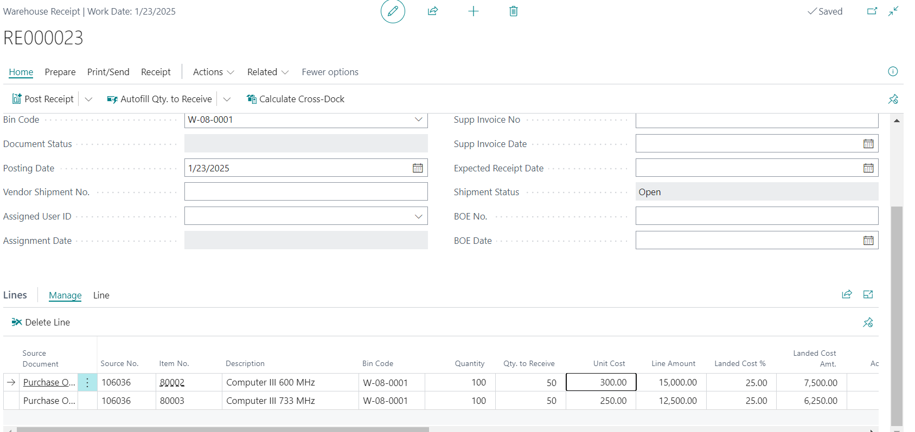

Posted Warehouse Receipt:

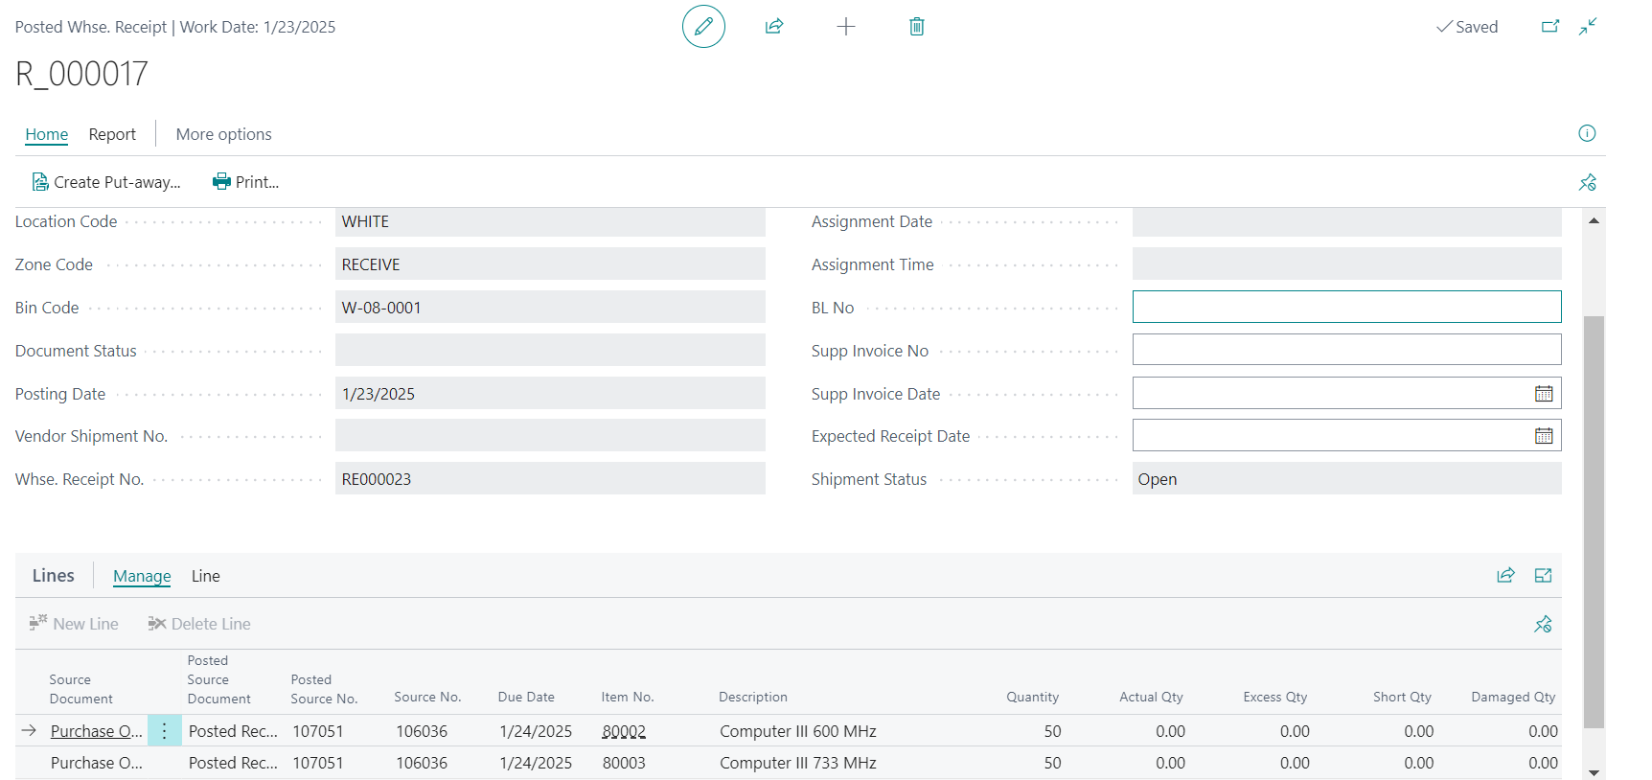

Value Entries:

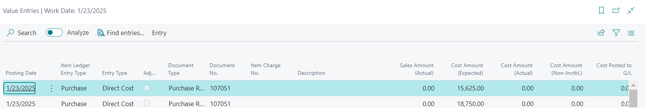

Purchase Invoice:

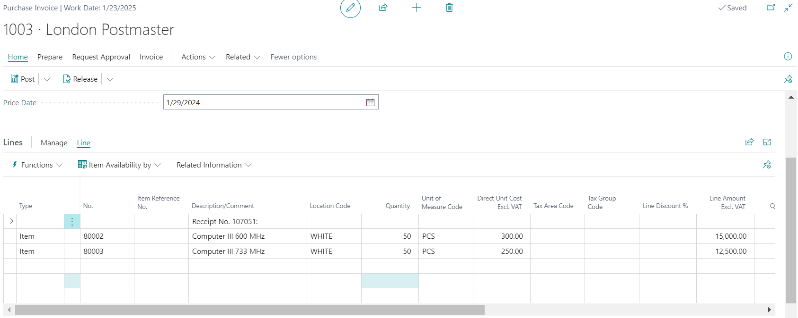

After Purchase Invoice Posted : Value Entries

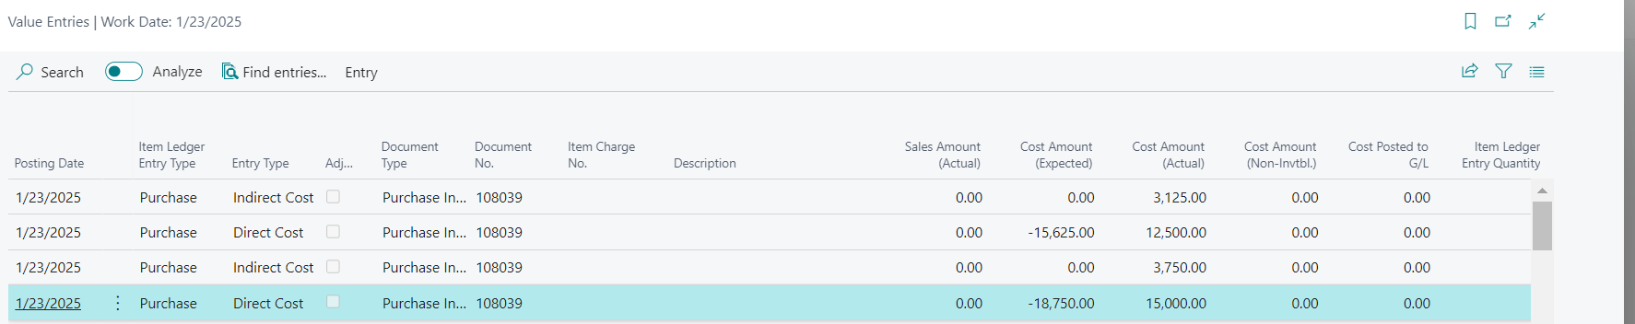

GRN-2

Cost WorkSheet:

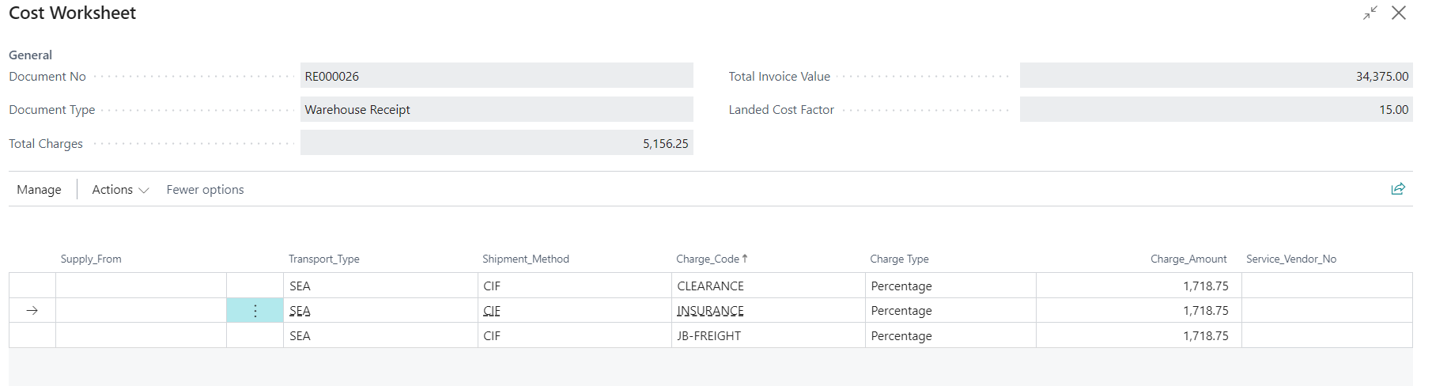

Warehouse Receipt:

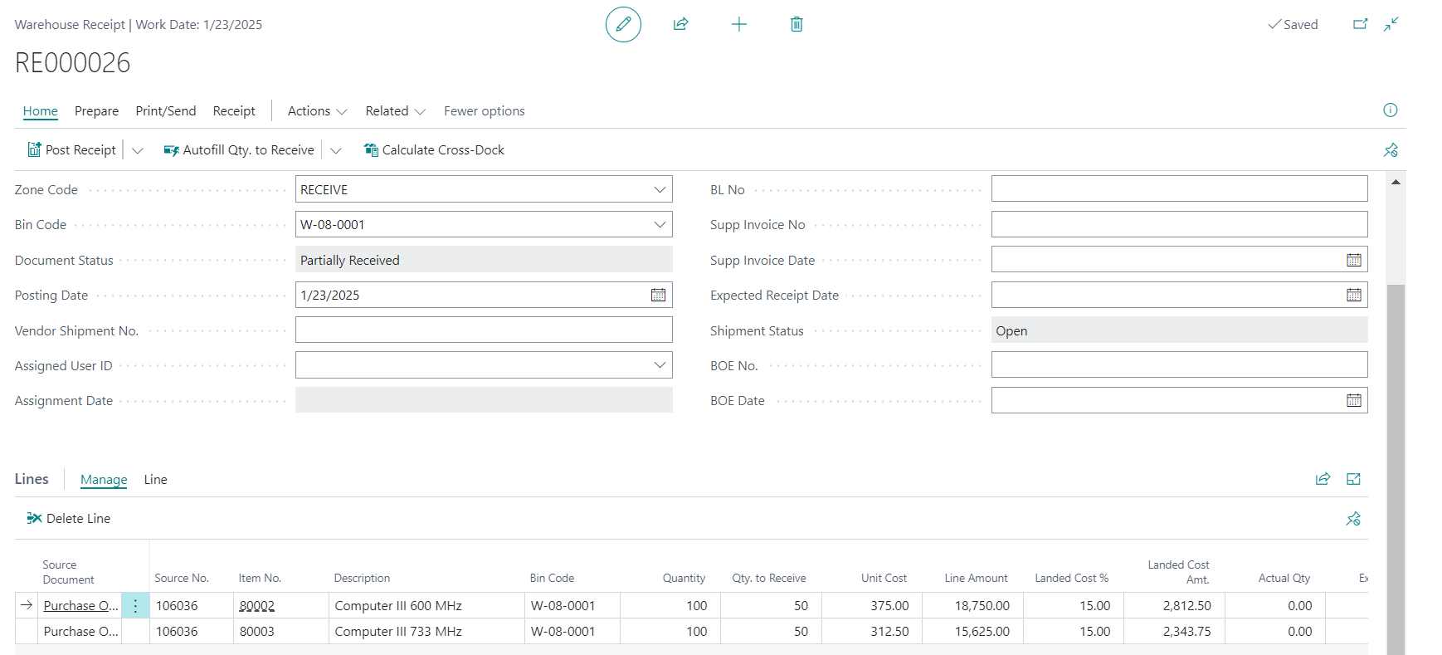

Posted Warehouse Receipt:

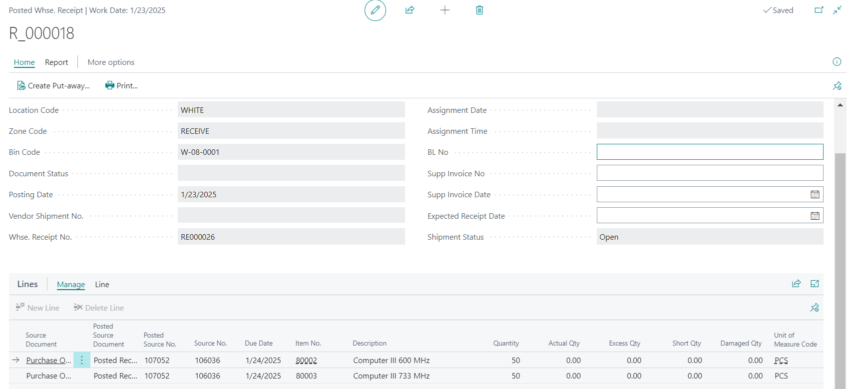

Value Entries:

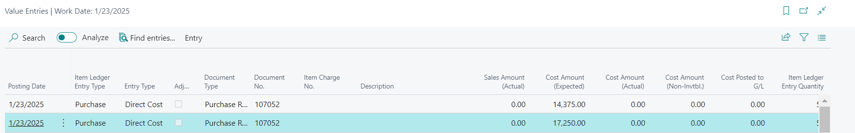

Purchase Invoice:

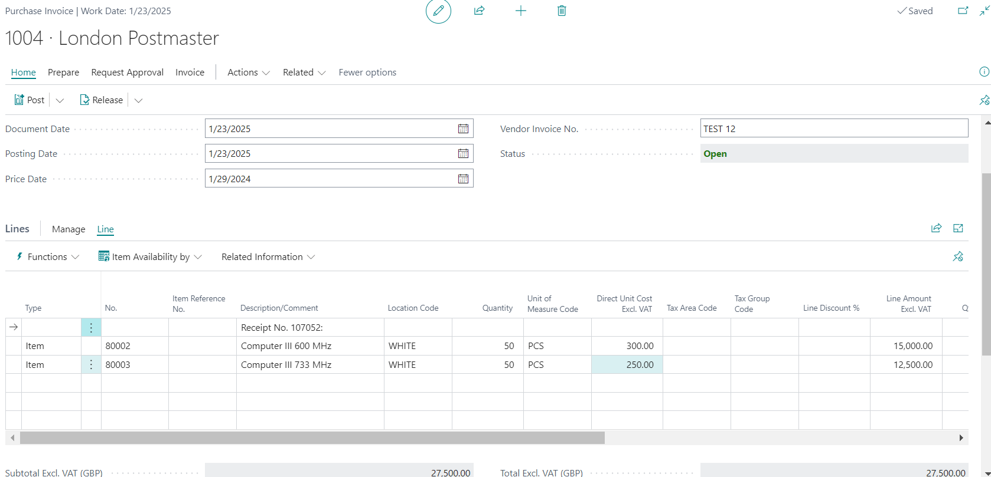

After Purchase Invoice Posted : Value Entries

